2.1.3 Utility Shed Design Guide—Part 3

Procedure
In this activity you will use Autodesk® Revit® 2016 to revise building components of the Utility Shed 3D model (created in Activity 2.1.3 Parts 1 and 2), create a wall section, and update your Utility Shed construction drawing.

Constraints
The utility shed must have the following attributes:
- 12 ft × 16 ft footprint
- 8 ft wall height
- One exterior wall should include brick
- Three exterior walls with 2 × 4 wood frame construction and siding
- 6 in. concrete floor
- Gable roof
- One single panel exterior door
- At least two windows

Deliverables
B-sized construction drawing (11” × 17”) to include the following views
      - 3D view
      - Dimensioned floor plan
      - Two Elevation views
      - Wall section

Revit® Instructions
Open your Green Utility Shed Project
Continue to build and revise the Green Utility Shed model that you created per Activity 2.1.3 Part 2 according to the following instructions.

Step 16—Create a Wall Section  A wall section will describe all of the interior components of a wall.  - Open the Floor Plan.  - Under the View tab, select the Section tool in the Create panel.  We will “cut” a section through a wall such that the resulting section view shows the slope of the roof (not the tall gable end of the shed). Remember the roof edges that were marked as Defines Slope when you created the roof? | 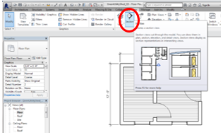
- In the graphics window, click on each side of a wall from which the roof slopes up. Note the cutting plane line that appears. The blue box defines the extent to which the section view shows building components. We want to see only “inside” the wall, so drag the far edge of the box to include only a narrow sliver of the wall using the blue arrow grips.
Notice that a section view is now included in the Project Browser.
- Open the Section 1 view from the Project Browser.  - Adjust the crop box to show the eave of the shed.  - Change the Detail Level to Fine.  - Change the view scale to ½” = 1’-0”. | 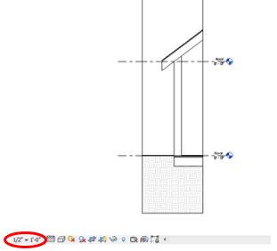
- Select one of the shed walls with siding. Perform the necessary actions to change the metal stud layer in the wall to a 4” Softwood, Lumber (actual dimension is 3-1/2”). Change the thickness of the Plywood sheathing to ½”. Click OK.  If you get an error message that says that constraints are not met, choose Remove Constraints. | 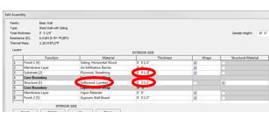
- Select the floor. Perform the necessary actions to duplicate and then edit the Floor to include a single 6 in. layer of concrete. Click OK.  - If necessary, edit the floor boundary to align with the outside faces of the walls.  - If necessary, edit the shed dimensions to reflect the required building size. | 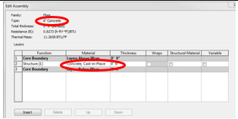
- Open the Section 1 view again.  - Under the Annotate tab, select the Text tool within the Text panel. Then under the Modify | Place Text tab, select the two segment leader line option within the Format panel. | 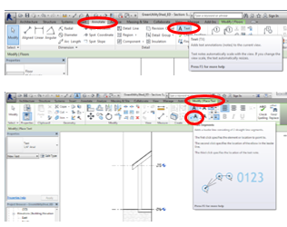
- Label each of the following components in the wall section.  - ½” Gypsum wallboard  - Cedar siding  - ½” Plywood sheathing (roof, floor, and wall)  - 2 × 4 Studs @ 24” O. C.  - 2 × 8 Rafters @ 24” O. C.  - Asphalt shingles  - 6” Concrete slab  Note that O. C. stands for “on center”.  - Under the Annotate tab, use the Insulation tool within the Detail panel to place the insulation symbol within the wall and roof. Be sure to adjust the thickness to match the thickness of the wall studs and roof rafters, as appropriate. Label the batt insulation.  - Turn off the crop box for the section view.  - Open the appropriate elevation view and annotate the roof slope using the Detail Line tool within the Detail panel and the Text tool within the Text panel. (You may revise your roof slope, if desired, by selecting the roof, editing the roof footprint, selecting the appropriate roof edge, and changing the slope value.) | 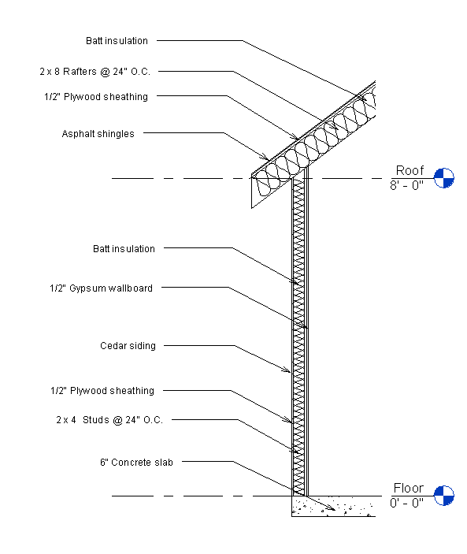  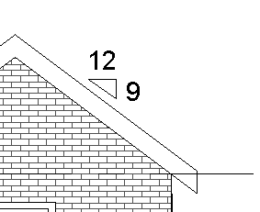
- Add the section view to your drawing. You may need to move views, adjust crop boxes, and move view labels in order to properly display all views.  - Note that once the section view is added to the sheet, the cutting plane line indicated on the floor plan shows the view number and drawing sheet on which the section view appears. | 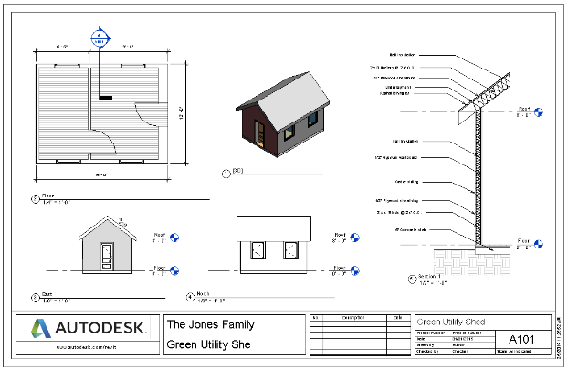
Technically, because there are two types of walls, you should provide another wall section to detail the construction of the brick wall.  - (Optional) Duplicate and edit the brick wall to include 2 × 4 wood (studs) instead of 2 × 6 metal studs. Then create another wall section of the brick wall. | Note that the section view shown above includes a toposurface and therefore includes the ground surface and soil. This is an optional component of this project and may not appear in your section view.

